Technical specification LBAi W GATE Single
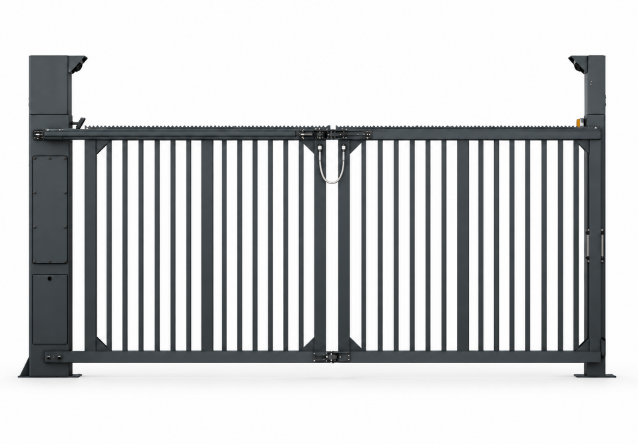
Tender documents:
The ultra-fast folding gate shall be reliable and robust, designed for intensive, continuous operation with a 4 m clear opening.
It shall comply with standard 13241-1 and be validated by CSTB, with installation requiring no additional safety photocells or safety edges. It shall meet the following specifications:
Technical specifications
- Custom height from 2 to 3 m
- Single: 2 leaves, 3 to 5 m
- 6 mm thick steel pivot post – 350 x 250 mm cross-section
- Anti-corrosion e-coat treatment
- Powder coating baked at 250°, with a choice of RAL colours: White 9010, Grey 7016, Green 6005, Red 3020 or Black 9005
- Aluminium leaves with 30 x 30 mm bars and variable spacing suited to the gate length, not exceeding 110 mm
- Concealed drive integrated into the pivot post, accessible through a dedicated door below the control compartment door
- Control system accessible through two doors integrated into the pivot post, with access when the gate is open or closed.
- (exposed motors and/or separate control cabinets shall not be permitted)
Equipment
- Reversible geared motor
- Brake motor enabling the gate to be locked in the event of a power failure
- Manual release from the motor compartment
- Opening speed of 1.2 m/s
- Force limiter in the event of impact
- 2 sets of IR photocells with transmitter/receiver
- Contactless inductive sensors for position control
- Held in the open or closed position
- 90° opening
- Access doors fitted with anti-vandalism compression locks
- LED area lighting
- 500 kg electromagnetic lock
- 2 anchoring templates with anchor rods
- Lifting eyes for easy, safe positioning by installers
Integrated ONE-C control board
- Hardwired or network cable control; several communication protocols (Modbus TCP/IP, RS485)
- Centralised communication interface (LED display)
- Remote configuration and control via web server
- Variable-frequency motor control to adjust:
- Acceleration and braking ramps
- Opening and closing speeds
- SD card updates with a single program
- Plug-in terminal block
LBAi functions
- Integrated detection without ground loops or additional infrared photocells
- No detection-related civil works and reduced wiring requirements
- Recognition of 7 user categories: pedestrians, bicycles, motorcycles, cars, vans, trucks and buses
- Up to 5 configurable detection zones
- Range up to 10 m
- 170° horizontal and 70° vertical coverage
- Precise settings to limit unwanted detections
- Configurable access permissions by category
- Management of access authorisations and denials
- Customisable time schedules
- Configuration via a secure local Wi-Fi connection, independent of the site's network
- Continuous day and night operation with reliable performance in adverse weather
- Activity log available to assist diagnostics
- Simple updates via SD card
- Planned upgrades: vehicle counting and future recognition of specific vehicles
Options to include in the tender documents if selected
- 115° opening
- Alternative colour to be selected from the RAL chart
- Perforated aluminium infill panel with an LBA Design pattern
- Ø60 mm LED light mounted on the receiver post
- Controlled red/green LED strip
- Additional 500 kg electromagnetic lock
Compliance
- Compliant with standard 13241-1
- Validation by CSTB (French Scientific and Technical Centre for Building) without additional safety edges or photocells

