Technical specification LBAi 10
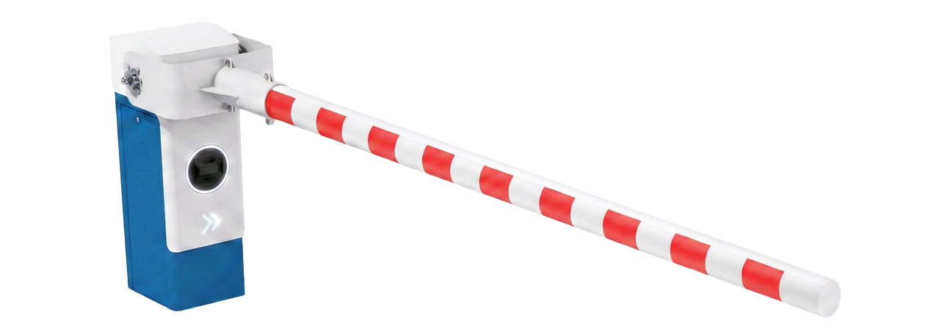
Tender documents:
The automatic barrier shall be robust and designed for intensive, continuous operation. It shall be a LA BARRIÈRE AUTOMATIQUE LBA 10. The barriers shall accommodate straight fibreglass booms and meet the following specifications:
The barrier shall incorporate LBAi intelligent detection, user classification and access rule management functions.
Technical specifications
- Housing and door made from 3 mm thick DKP steel sheet with an e-coat finish.
- Cover made from 2 mm thick aluminium sheet with a phosphate treatment.
- 10,000 operations/day
- Variable operating time from 2 to 7 seconds
- Three-phase motor and 230 V single-phase power supply
Equipment
- Axial Ø140 mm reinforced fibreglass boom, up to 10 m in one piece without guy wires. This composite boom shall provide greater flexibility in the event of impact. It is particularly suitable for managing heavy goods vehicle traffic.
- Reinforced mounting bracket
- Barrier housing with a self-locking or reversible geared motor
- Counterbalance with a compression spring (torsion or tension springs are too fragile)
- Contactless inductive sensors for barrier control.
- Held in the open or closed position
Integrated ONE-C control board
    - Hardwired or network cable control; several communication protocols (Modbus TCP/IP, RS485)
    - Centralised communication interface (LED display)
    - Certified PL-d, Category 2, under EN ISO 13849-1
    - Remote configuration and control via web server
    - Variable-frequency motor control to adjust:
    - Acceleration and braking ramps
    - Opening and closing speeds
    - SD card updates with a single program
    - Plug-in terminal block
LBAi functions
- Integrated detection without ground loops or additional infrared photocells
- No detection-related civil works and reduced wiring requirements
- Recognition of 7 user categories:
- Pedestrians, bicycles, motorcycles, cars, vans, trucks and buses
- Up to 5 configurable detection zones
- Range up to 10 m
- 170° horizontal and 70° vertical coverage
- Precise settings to limit unwanted detections
- Configurable access permissions by category
- Management of access authorisations and denials
- Customisable time schedules
- Configuration via a secure local Wi-Fi connection, independent of the site's network
- Continuous day and night operation with reliable performance in adverse weather
- Activity log available to assist diagnostics
- Simple updates via SD card
- Planned upgrades: vehicle counting and future recognition of specific vehicles
Options to include in the tender documents if selected
- Impact-protection rotation mechanism
- Manual rotation of the housing shall prevent breakage if a vehicle strikes or forces the barrier.
- After an impact, the boom shall be repositioned manually without tools or any specific work inside the housing.
- The system shall operate by friction on the anchoring template, ensuring that the boom moves no further than the vehicle pushes it. (No ball bearings or repositioning pins requiring a technician's intervention.)
- Choice of RAL colour
- Automatic raising in the event of a power failure
- Boom support with rubber damper
- Boom support with electromagnetic lock
- Internal locking mechanism preventing manual raising
- Anti-vandalism package (reinforcing band, bolt covers and accessory guards)
- Signs, audible and visual signalling
- LED cover (red/green)

Technical data
- MCBF (mean cycles between failures): 10,000,000 cycles
- MTBF (mean time between failures): 15,000 hours
- Daily operating cycles: 10,000 operations per day
- MTTR (mean time to repair): 60 minutes
- Ingress protection rating: IP54

