Technical specification LBAi 86
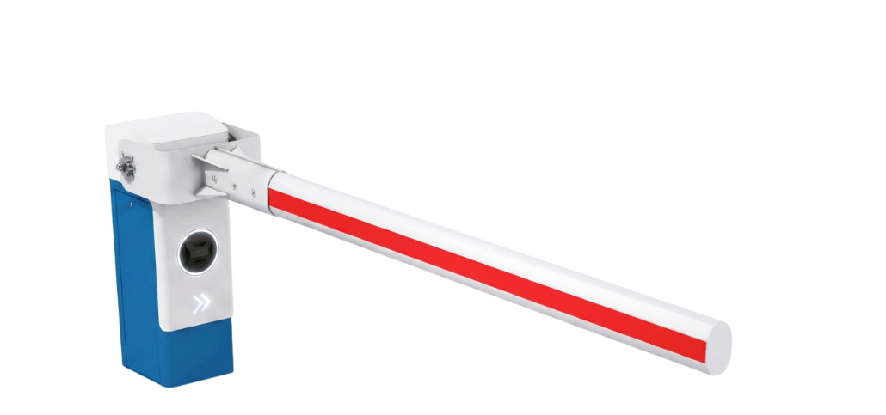

Tender documents:

The automatic barrier shall be robust and designed for intensive, continuous operation in high-security environments.
It shall be a LA BARRIÈRE AUTOMATIQUE LBAi 86.
The barrier shall incorporate LBAi intelligent detection, user classification and access rule management functions.

Technical specifications:
- Housing and door made from 3 mm thick DKP steel sheet with an e-coat finish
- Cover made from 2 mm thick aluminium sheet with a phosphate treatment
- Intensive, continuous operation: 10,000 operations/day
- Variable-speed opening/closing, from 2 seconds depending on boom length and configuration
- Three-phase motor and 230 V single-phase power supply

Equipment:
- Reinforced axial boom:
    - 180 x 118 mm straight boom: up to 6 m
    - 135 x 93 mm oval boom: up to 8 m
- Reinforced mounting bracket
- Barrier housing with a reversible geared motor
- Counterbalance with a compression spring
- Integrated anti-vandalism and anti-intrusion package
- Angular sensor indicating boom position to within one degree
- Held in the open or closed position
- Set of keys for the door lock
- Integrated ONE-C control board:
    - Hardwired or network cable control; Modbus TCP/IP and RS485 protocols
    - Certified PL-d, Category 2, under EN ISO 13849-1
    - Centralised communication interface with LED display
    - Remote configuration and control via web server
    - Variable-frequency control for adjusting acceleration and braking ramps
    - Adjustable opening and closing speeds
    - SD card updates with a single program
    - Plug-in terminal block

LBAi functions:
- Integrated detection without ground loops or additional infrared photocells
- No detection-related civil works and reduced wiring requirements
- Recognition of 7 user categories:
    - Pedestrians, bicycles, motorcycles, cars, vans, trucks and buses
- Up to 5 configurable detection zones
- Range up to 10 m
- 170° horizontal and 70° vertical coverage
- Precise settings to limit unwanted detections
- Configurable access permissions by category
- Management of access authorisations and denials
- Customisable time schedules
- Configuration via a secure local Wi-Fi connection, independent of the site's network
- Continuous day and night operation with reliable performance in adverse weather
- Activity log available to assist diagnostics
- Simple updates via SD card
- Planned upgrades: vehicle counting and future recognition of specific vehicles

Options to include:

- Choice of RAL colour
- Boom support with rubber damper
- Automatic raising upon loss of power, depending on configuration

Technical data:
- MCBF (mean cycles between failures): 10,000,000 cycles
- MTBF (mean time between failures): 15,000 hours
- Operating temperature: -30°C to +55°C
- Ingress protection rating: IP54

