Technical specification LBAi 63PK
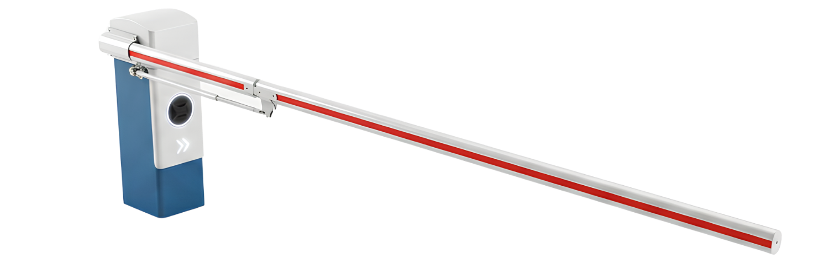Tender documents:
The automatic barrier shall be robust and designed for intensive, continuous car park operation. It shall be a LA BARRIÈRE AUTOMATIQUE LBA 63PK. The barriers shall accommodate straight or articulated oval aluminium booms and meet the following specifications:
The barrier shall incorporate LBAi intelligent detection, user classification and access rule management functions.
Technical specifications
- Housing and door made from 2 mm thick DKP steel sheet with an e-coat finish
- Cover made from 2 mm thick aluminium sheet with a phosphate treatment
- 15,000 operations/day
- Opening/closing time from 0.8 to 2.4 seconds
- Three-phase motor and 230 V single-phase power supply
Equipment
- 84 x 57 mm straight or universal articulated oval aluminium boom with reflective strips, up to 3.80 m
- The articulated boom shall require no advance measurements by the installer. It shall be fitted on site regardless of the available ceiling clearance.
- Breakaway boom secured by a stainless steel screw and nylon nut
- Breakaway boom detection
- Automatic reopening upon loss of power
- Barrier housing with a reversible geared motor
- Compression-spring counterbalance (tension or torsion springs prohibited for reliability reasons)
- Angular sensor indicating boom position to within one degree.
- Held in the open or closed position
- Set of keys for the door lock.
Integrated ONE-C control board
    - Hardwired or network cable control; several communication protocols (Modbus TCP/IP, RS485)
    - Certified PL-d, Category 2, under EN ISO 13849-1
    - Centralised communication interface (LED display)
    - Remote configuration and control via web server
    - Variable-frequency motor control to adjust:
    - Acceleration and braking ramps
    - Opening and closing speeds
    - SD card updates with a single program
    - Plug-in terminal block
LBAi functions
- Integrated detection without ground loops or additional infrared photocells
- No detection-related civil works and reduced wiring requirements
- Recognition of 7 user categories:
- Pedestrians, bicycles, motorcycles, cars, vans, trucks and buses
- Up to 5 configurable detection zones
- Range up to 10 m
- 170° horizontal and 70° vertical coverage
- Precise settings to limit unwanted detections
- Configurable access permissions by category
- Management of access authorisations and denials
- Customisable time schedules
- Configuration via a secure local Wi-Fi connection, independent of the site's network
- Continuous day and night operation with reliable performance in adverse weather
- Activity log available to assist diagnostics
- Simple updates via SD card
- Planned upgrades: vehicle counting and future recognition of specific vehicles
Options to include in the tender documents if selected
- Choice of RAL colour
- Aluminium housing
- Rear swing-away mechanism
- LED cover
- Illuminated boom
- Foam-padded boom
- Forced-entry attempt alarm
- Internal anti-tamper locking device
- Boom support with rubber damper (excluding breakaway or swing-away boom options)
- Boom support with electromagnetic lock (excluding breakaway or swing-away boom options)
- Boom support with electromechanical lock (excluding breakaway or swing-away boom options)
Technical data
- MCBF (mean cycles between failures): 10,000,000 cycles
- MTBF (mean time between failures): 15,000 hours
- Daily operating cycles: 15,000 operations per day
- MTTR (mean time to repair): less than 15 minutes
- Ingress protection rating: IP54

